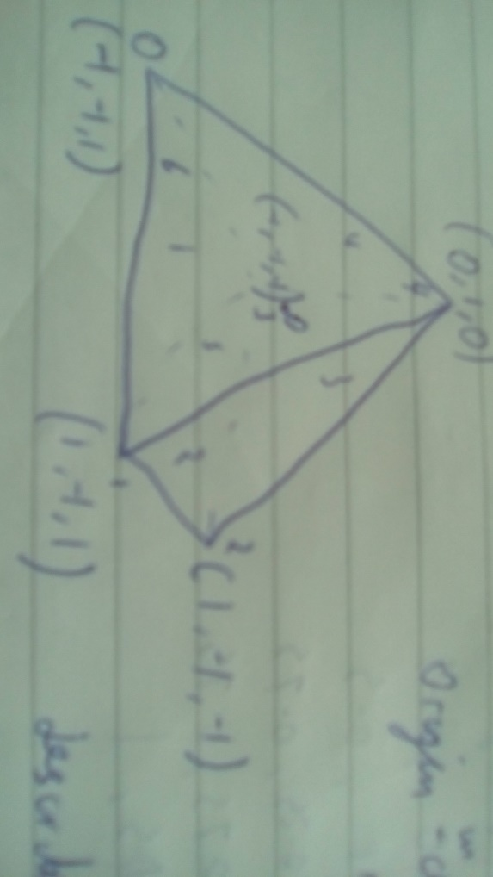

**(a)**

**Vertex List**

|  |  |  |  |
| --- | --- | --- | --- |
|  | x | y | z |
| 0 | -1 | -1 | 1 |
| 1 | 1 | -1 | 1 |
| 2 | 1 | -1 | -1 |
| 3 | -1 | -1 | -1 |
| 4 | 0 | 1 | 0 |

**Index List**

|  |  |  |  |
| --- | --- | --- | --- |
| 0 | 4 | 0 | 1 |
| 1 | 4 | 1 | 2 |
| 2 | 4 | 2 | 3 |
| 3 | 4 | 3 | 0 |
| 4 | 3 | 2 | 1 |
| 5 | 3 | 1 | 0 |

**(b)**

Origin -in centre of mass of object so rotations and scaling does not affect position

Describe faces in the same direction (Counter-clockwise)

**(c)**

**(i)** provides mapping points on an object to be textured

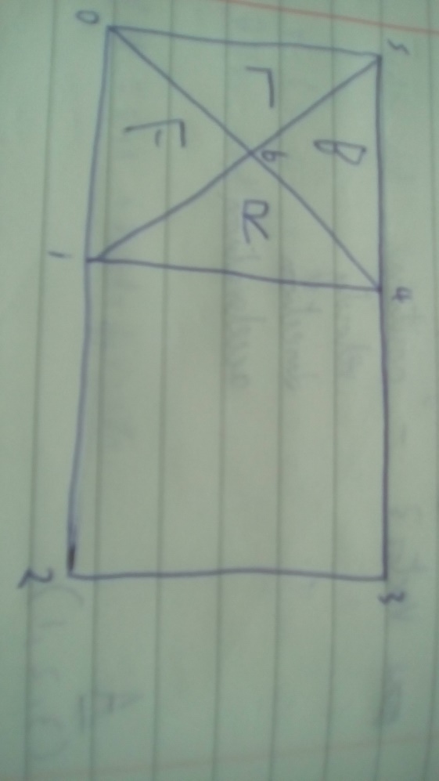

**(ii)**

**Texture vertex list**

|  |  |  |
| --- | --- | --- |
|  | u | v |
| 0 | 0 | 0 |
| 1 | 0.5 | 0 |
| 2 | 1 | 0 |
| 3 | 1 | 1 |
| 4 | 0.5 | 1 |
| 5 | 0 | 1 |
| 6 | 0.25 | 0.5 |

|  |  |  |  |
| --- | --- | --- | --- |
| **Front(0)** | **6** | **0** | **1** |
| **Right(1)** | **6** | **1** | **4** |
| **Left(3)** | **6** | **5** | **0** |
| **Back(2)** | **6** | **5** | **4** |
| **Base1(4)** | **4** | **3** | **2** |
| **Base2(5)** | **4** | **2** | **1** |